JC2002 Assessment Report
Hao Gu
Student id: 50098805
- Introduction
Cryptography is a complex and systematic discipline that has undergone extensive development. It has evolved from the simple character shifting of the Caesar cipher to the sophisticated and diverse encryption algorithms and rigorous key management systems of today. Through this task, I have studied and gained an understanding of the Caesar cipher along with other cryptographic knowledge. I have completed the design and implementation of encryption and decryption programs for the Caesar cipher, and conducted program invocation and testing through different interfaces.
This project encompasses core concepts of Java object-oriented programming, including class construction, method encapsulation, string processing, array operations, and file I/O techniques. Initially, a CaesarCipher class was constructed with encryption methods encapsulated through a key parameter. Subsequently, string processing to identify the character with the highest frequency became crucial for decryption. In Caesar cipher decryption, since it constitutes the inverse operation of encryption where keys demonstrate complementarity, the decryption process actually re-invokes the CaesarCipher.encrypt() method. Furthermore, when handling multiple keys, the essential approach involves partitioning the message by position to achieve decoupling and enable divide-and-conquer strategy ^{[1]}. Finally, different classes provide distinct interfaces for Main and Test classes to instantiate and invoke.
//第一部分，解耦和分治可以有引用。
//太长啦
- Device Class Design
The implementation of this program strictly adheres to object-oriented design principles, with core functionalities accomplished through the collaboration of three encryption/decryption classes and two driver test classes. The overall class structure is depicted in the following UML diagram:
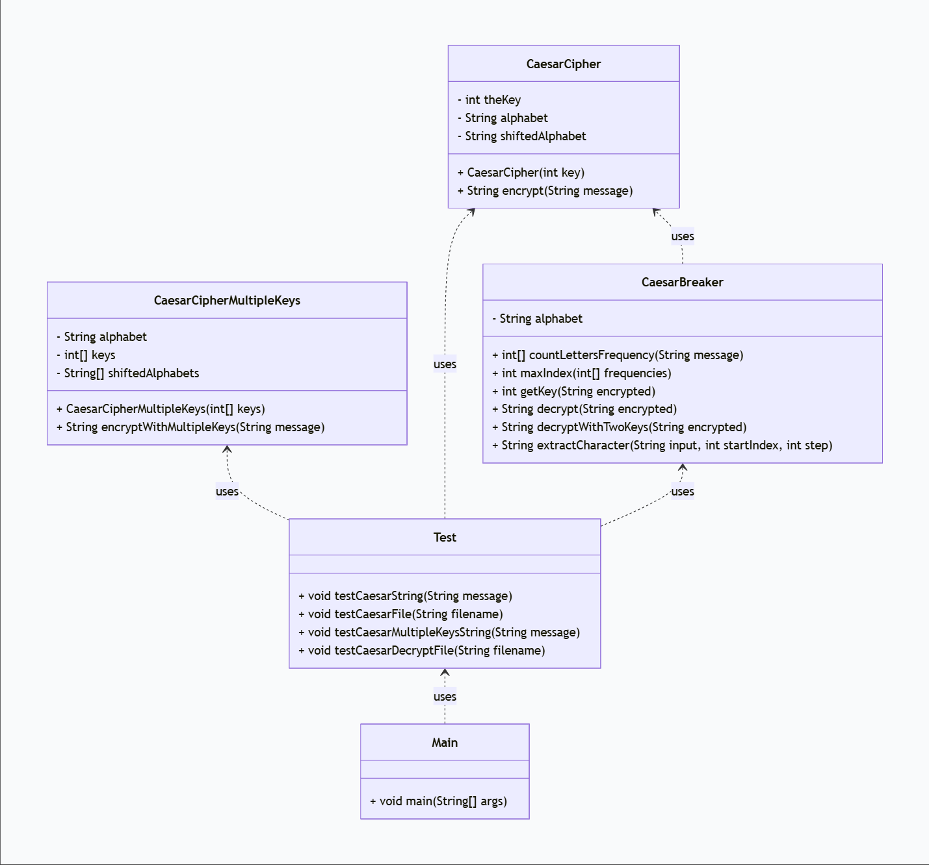
Implementation of Single-Key Encryption/Decryption:
//tupian
- Constructor: The constructor accepts an integer key. Its core operation is to generate a corresponding shifted alphabet based on the key and the standard 26-letter alphabet. The algorithm for the shifted alphabet is: extract a substring from the end of the standard alphabet with a length equal to key, and then concatenate it with the remaining portion.
shiftedAlphabet = alphabet.substring(key, 26) + alphabet.substring(0, key);
- Encryption Algorithm: This method iterates through each character of the input string. First, it checks if the character is a letter; if not, it skips it directly. For each letter character, it is first converted to uppercase and its position index is located in the standard alphabet. Then, the corresponding character from the shifted alphabet at the same index is taken as the encryption result. Subsequently, it determines whether to convert the result back to lowercase. Finally, the new character replaces the original letter, and the encrypted text is returned.
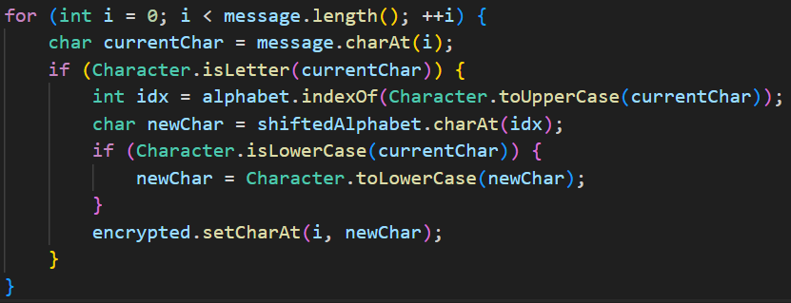
- Decryption Mechanism: Decryption of the Caesar cipher is essentially the inverse process of encryption. In the CaesarBreaker class, the class method countLettersFrequency analyzes the letter frequency within the text to obtain the most probable key. Decryption is then achieved by creating a new CaesarCipher object with the complementary key 26 - key and calling its encrypt method.
CaesarCipher cc = new CaesarCipher(26 - key);String message = cc.encrypt(encrypted);

Implementation of Double-Key Encryption:
//tupian
- Multi-key Encryption (encryptWithMultipleKeys): The constructor accepts an array of keys, and a corresponding shifted alphabet is pre-generated for each key and stored in the shiftedAlphabets array. During encryption, the method iterates through each character of the message string. Based on the character's index modulo the length of the shiftedAlphabets array, it decides which key to use.
int keyIndex = i % keys.length;
The process is then identical to single-key encryption.
- Double-Key Decryption (decryptWithTwoKeys): In the CaesarBreaker class, cracking a ciphertext encrypted with two keys employs a divide-and-conquer approach. First, the ciphertext is split into two substrings using the helper method extractCharacter. Then, by applying the inverse operation of the encryptWithMultipleKeys method, the plaintext can be obtained.
for (int i = startIndex; i < input.length(); i += step) {
result.append(input.charAt(i));
}
Main and Test Classes:
The Test class and the Main class together form the system's integrated test suite. The testing involves both passing strings directly to the corresponding encryption classes and reading text content from files before passing the strings to the encryption classes.
String message = new String(Files.readAllBytes(Paths.get(fileName)));
In summary, the implementation of the Caesar cipher encryption and decryption process focuses on the key search and transfer processes and logic.
- Reflective Account
//我暂时还不知道写什么
//虽然遇到了问题，但已经解决了。
//遇到的问题，没能解决。
//可以改进的方向
The program uses dictionaries (devices) to map device IDs to device objects. Meanwhile, add '*devices' to enable batch joining of devices.
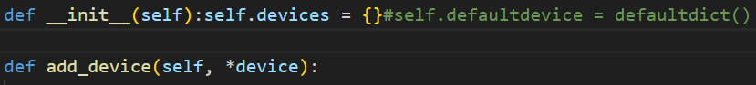
A dictionary has the following advantages:
- O (1) Time complexity addition, deletion, and search operations.
- Ensure the device ID is unique, ensuring data security.
- Efficient memory storage and mapping based on hash table.
After studying and carefully considering defaultdict ^{[1]}, I want to suggest that defaultdict haven’t been adopted. Because defaultdict automatically creates key value pairs, incorrect operations may contaminate the dictionary. Therefore, I still use traditional dictionaries and manually maintain them.
Device controller class has four main methods.
- Add device:
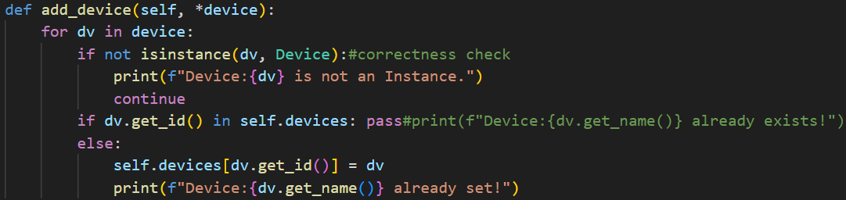
Traverse each new device through a for loop. Since each class object is already added to the dictionary during initialization, if conditional statements skip the addition operation, aiming to improve code execution efficiency. This check ensures that each device ID remains unique, maintaining the integrity of the system.
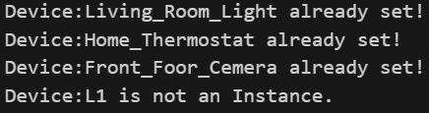
- List device:
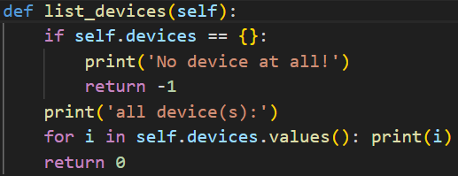
Call the built-in Python function '__str__' to output the devices and its attributes. Use '\t' to make the output content more aesthetically pleasing.
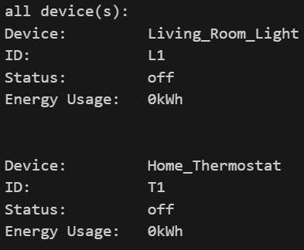
- Execute command:
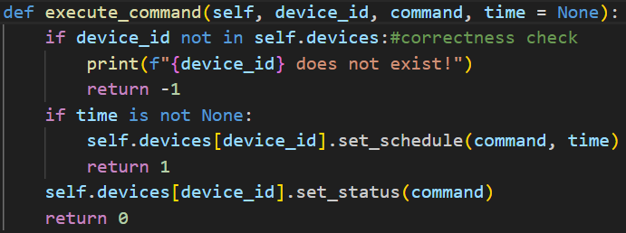
A default argument, 'time', is provided in this function, which provides reusable code for the function schedule_task().In this function, correctness checking of arguments is also required, checking and returning non-existent device IDs. Finally, by using the default parameter 'time', call function set_schedule() and function set_status() separately to achieve different effects and achieve function overloading.
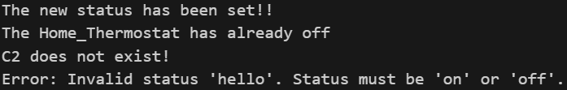
- Remove device:
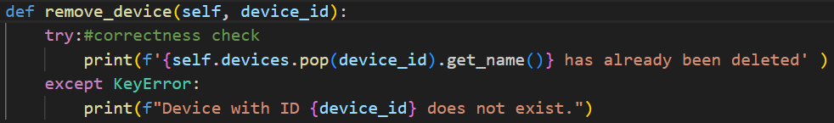
The remove_device() method allows for the removal of devices from the system by their IDs. To simplify the code, the 'try-except' method is used here instead of traditional correctness checking. Provide a unified error message for possible errors, such as incorrect ID, non-existent ID, inability to delete, etc. Exclude potential hazards in the code and comply with OOD safety and concise design requirements.
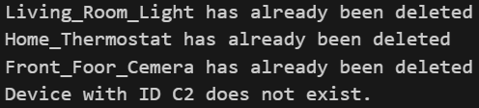
- Smart Home Hub Class Design
SmartHomeHub and DeviceController are both unique, so a singleton needs to be created for them. This can avoid creating multiple instances, which can interfere with each other and affect code efficiency.
The Singleton pattern is implemented by overriding the __new__() method. When calling the constructor, if _instance is NONE, create an instance SmartHomeHub and assign it to _instance, while initializing DeviceController. Otherwise, return the value of _instance.
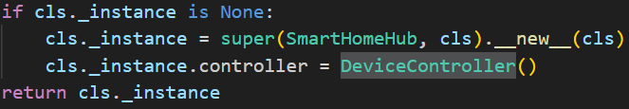
Device controller class has three main methods.
- Schedule task^{[2][3]}:
In this method, code reuse is achieved directly by using the default parameters in the method execute_command(). At the same time, the default parameter 'time=None' is retained in this method, which modifies the current device state.
- Display status:
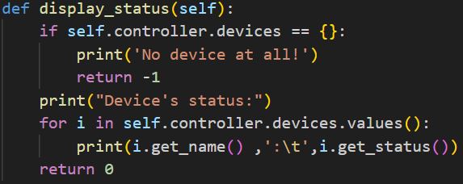
In this method, a for loop is used to call instances in the dictionary one by one and print their names and statuses. Simultaneously using '\t' to make the output more aesthetically pleasing. It cannot be ignored that if the dictionary is empty, meaning there are no devices, additional output results need to be made.
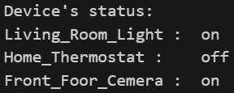
- Total energy usage:
In this method, the built-in iterators^{[4]} in Python are fully utilized to iterate through the values in each dictionary, that is, each device, and recursively accumulate them to obtain the total energy consumption.
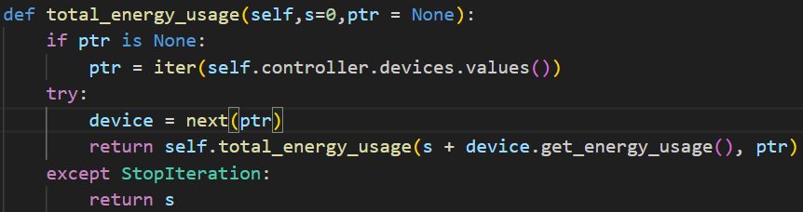
In recursion, we need to maintain the total energy 's' and the iterator pointer. Call the method get_energy_usage() to accumulate the sum 's' and point the iterator pointer to the next value. Thus achieving the use of iterators and recursion to calculate the total energy consumption.
SmartHomeHub calls methods in the Controller through self.controller and further passes arguments to them. In fact, the SmartHomeHub class is tightly integrated with the DeviceController class to form a cohesive and functional system. In DeviceController, a dictionary that can be mapped to devices and basic methods for managing devices are stored. In SmartHomeHub, various abstract methods are encapsulated to meet different real-world needs. This includes reservation functions, calculating total energy consumption, and so on.This shows that the abstract methods in SmartHomeHub need to repeatedly call the DeviceController interfaces to achieve interaction between various subclasses, that is, devices.
- Testing and Demonstration
The testing approach for the Smart Home Automation System involves using the Python unittest^{[5]} framework to ensure the reliability and correctness of the implementation. Common testing methods include using assert statements to compare whether the correct answer is given.
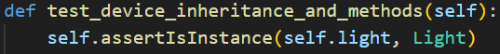
Obviously, the test samples built by the unittest framework in the test.py file are not sufficient to test the entire system. Therefore, I have written some additional test samples for edge testing.
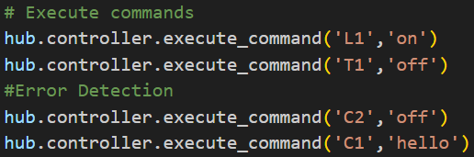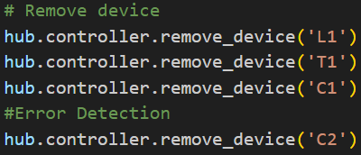
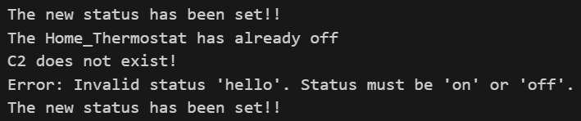
Above all, automated tests play a crucial role in maintaining the quality of the system.
Due to the fact that the class Devices does not provide an interface to outside, it is difficult for us to explicitly test the methods within it. However, the execute_command() and schedule_task() in Controller can implicitly test whether there are errors in the methods in Devices. 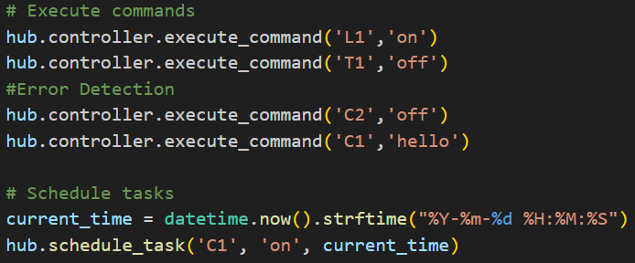
For the classe DeviceController and SmartHomeHub, we have already provided a detailed introduction to the core code and results in the previous section. We will not get into the specifics here, but only provide some test samples to the basic testing methods.
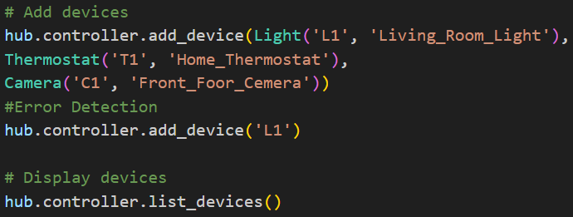
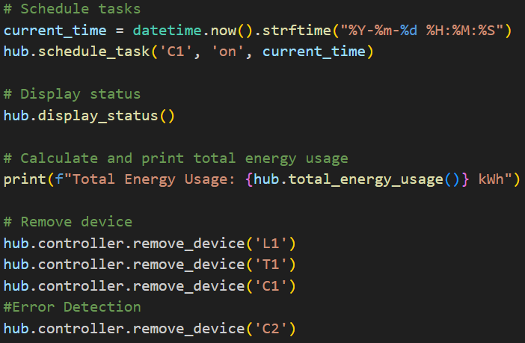
But these tests are not enough. I conducted additional testing on whether the SmartHomeHub class is a singleton. The results show that both addresses are the same, so it is a singleton.
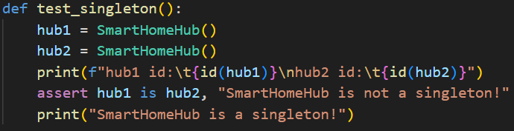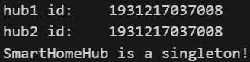
The test results show that all implemented tests pass, indicating that the system functions correctly and reliably.
- Conclusion
In this project, the smart home control system was completed beyond expectations. At the same time, the system has good work efficiency and operational capabilities. By implementing the system using Python's OOP features such as inheritance, polymorphism, encapsulation, and abstraction, we achieved the goals of adding/removing devices, commanding devices, monitoring system states, managing energy consumption, and scheduling tasks.
During the development process, the project presented numerous challenges, such as correctly implementing singleton patterns and ensuring proper interaction between objects. The experience gained from this project highlights the importance of OOP principles in creating scalable, maintainable, and efficient software systems.
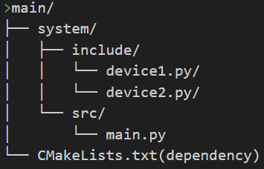
In the future, there is still room for improvement in this project. We can separate the source code containing subclasses of devices from the main function and call the subclass source code through dependencies. This project structure is clearer and helps to further expand the functionality of subclass devices.
- References
这里可以写UML图引用课程slides
代码注释，譬如说key的地方
在讨论初始凯撒密码和对密码进行深入研究时，需要引用
[1] oi 分治
[2] https://docs.python.org/3/library/datetime.html
[3] https://schedule.readthedocs.io/en/stable/
[4] https://docs.python.org/3/library/stdtypes.html#iterator-types
[5] https://docs.python.org/zh-cn/3/library/unittest.html

